CORPORATE ADVERTISING

Corporate advertising effects on market very long period of time, but does not effect on sales immediately. Also, corporate advertising has a strong cumulative effect, so the strategy of investments should be planned for all 5 periods. Effect on sales is different for each market. The greatest effect will be in the Internet. EU and Nafta have the same effect, but is less than in the Internet.

*It is important to remember that the effect of your investment comes after the period. If you spent 99 on corporate advertising in the Internet in 1 period, effect on sales you will get only in 2 period. That is why spending money on corporate advertising in the 5 period does not make sense, it would not effect on market at all.*

**Test 1 - EU and Nafta (2 period)**

Vertical - the relative market change compared with 1 period. Horizontally - the absolute value of corporate advertising. Results for EU and Nafta, reference points are the same, therefore the effect on sales are equal for both markets.

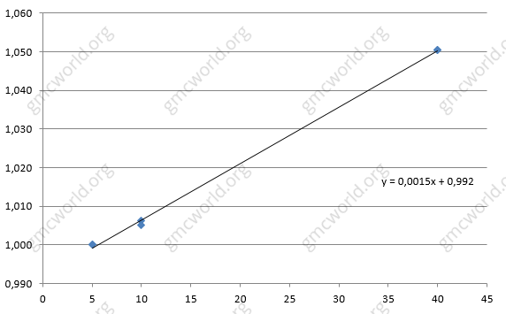

**Test 1 - Internet (2 period)**

The same results, but for the Internet market. Line has a greater slope, because the effect is stronger than in the EU and Nafta. The coefficient is 0.0018 against 0.0015 (or 0.0014). Coefficient means that every $1 000, invested in corporate advertising will make 1 * 0.0018 = 0.18% market increasing. $99 000 will make 99 * 0.0018 = 17.82% market increasing.

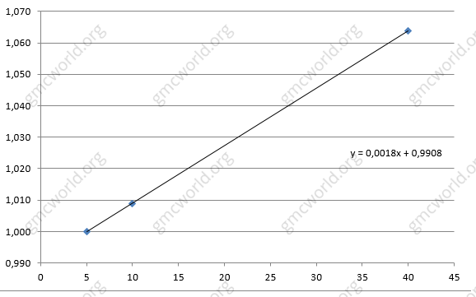

**Test 2 - EU and Nafta (3 period)**

We continue to test corporate advertising in 3 period.

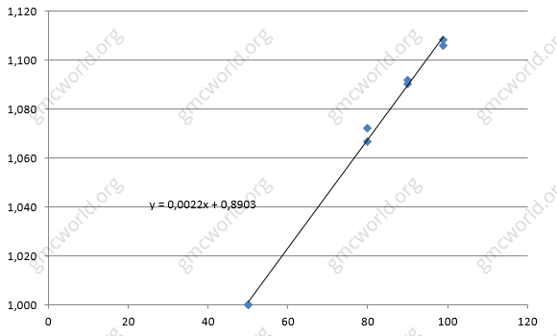

**Test 3 - EU and Nafta (4 period)**

We continue to test corporate advertising in 4 period.

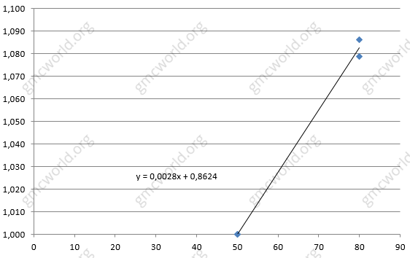

Corporate advertising has a strong cumulative effect, which is equal to 60% of previous investments. For perfect estimate, we made test with two teams in the same group, where all 5 periods corporate advertising was 50 and 80. The difference between sales in EU and Nafta can be calculated by the formula:

1. 2 period - (80-50) * 0.0014
2. 3 period - (80-50) * 0.0014 + (80-50) * 0.0014 * 0.6
3. 4 period - (80-50) * 0.0014 + (80-50) * 0.0014 * 0.6 + (80-50) * 0.0014 * 0.6 * 0.6

These specific features form strategy of investment in corporate advertising. You should maximize advertising budget at the beginning of the game for the market with great potential for growth, but gradually reduce it to 5 period:

1. 1 period - 99;
2. 2 period - 99;
3. 3 period - 85;
4. 4 period - 70;
5. 5 period - 0;

**Hints**

1. Cumulative effect - 60% of previous investments;
2. Effect of corporate advertising on market is proportional;
3. Effect is equal for products 1, 2 and 3;
4. Investments in the Internet market more profitable by 20%.

企业形象广告

企业广告对市场的影响很长一段时间，但不会立即对销售产生影响。 此外，企业广告累积效应较强，投资策略应计划在整五个时期。 对每个市场的销售影响是不同的。 最大的影响在于互联网。 国内和北美的效果相同，但比互联网少。

重要的是要记住，投资的效果是在此之后。如果您在一个时期内在互联网上花了99次企业广告，对销售的影响只能在2个时期内获得。这就是为什么在第5期花钱在企业广告上是没有意义的，它根本不会对市场产生影响。

**测试1 – 国内和北美（第2期）**

垂直－相对市场变化与1期相比。 水平－企业形象广告的绝对价值。国内和北美的结果是相同的，因此对两个市场的销售影响是相等的。



**测试1 - 互联网（第2期）**

同样的结果，但对于互联网市场。 线有更大的斜率，因为效果比国内和北美强。系数为0.0018，相对于0.0015（或0.0014）。 系数意味着投资企业广告的每1000美元将使市场增长1 * 0.0018 = 0.18％。 $ 99 000将使99 * 0.0018 = 17.82％的市场增长。



**测试2- 国内和北美（第3期）**

我们在第3期继续测试企业广告。



**测试3- 国内和北美（第4期）**

我们在第4期继续测试企业广告。



Corporate advertising has a strong cumulative effect, which is equal to 60% of previous investments. For perfect estimate, we made test with two teams in the same group, where all 5 periods corporate advertising was 50 and 80. The difference between sales in EU and Nafta can be calculated by the formula:

企业广告累积效应强劲，相当于以往投资的60％。 为了完美的估计，我们在同一组的两个团队进行了测试，其中所有5个时期的企业广告是50和80。国内和北美的销售额之间的差异可以通过以下公式计算：

1．第二期 - (80-50) * 0.0014

2．第三期 - (80-50) * 0.0014 + (80-50) * 0.0014 * 0.6

3．第四期 - (80-50) * 0.0014 + (80-50) * 0.0014 * 0.6 + (80-50) * 0.0014 * 0.6 * 0.6

 这些具体特征形成企业广告投资策略。 您应该在游戏开始时最大限度地发挥广告预算的潜力，并将其逐渐降至5期：

1．第一期 - 99;

2．第二期 - 99;

3．第三期 - 85;

4．第四期 - 70;

5．第五期 - 0;

**提示**

1．累计效应－60%对于以往投资；

2．企业形象广告对市场的影响是成正比的；

3．对产品1，2和3的效应是相当的；

4．互联网市场的投资更有利可图约20％。